CHEAT SHEET CTDL&GT

22, 1, 13, 11, 24, 33, 18, 42, 31

|  |  |  |  |  |  |  |  |  |  |
| --- | --- | --- | --- | --- | --- | --- | --- | --- | --- |
| key | 22 | 1 | 13 | 11 | 24 | 33 | 18 | 42 | 31 |
| h1 | 0 | 1 | 2 | 0 | 2 | 0 | 7 | 9 | 9 |
| h2 | 3 | 2 | 4 | 2 | 5 | 4 | 9 | 3 | 2 |

m = 11

h(key) = key mod m

h2(key) = key mod (m – 1) + 1

|  |  |  |
| --- | --- | --- |
|  | Dò bậc 2 | Băm kép |
| 0 | 22 | 22 |
| 1 | 1 | 1 |
| 2 | 13 | 13 |
| 3 | 24 |  |
| 4 | 11 | 11 |
| 5 |  | 18 |
| 6 |  | 31 |
| 7 | 18 | 24 |
| 8 |  | 33 |
| 9 | 33 | 42 |
| 10 | 42 |  |

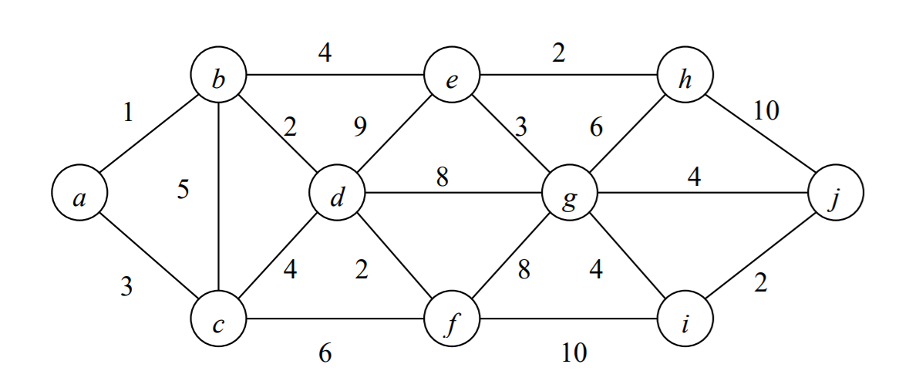

|  |  |
| --- | --- |
| Đỉnh | Priority Queue |
|  | a(0, null) |
| a(0, null) | b(1, a), c(3, a) |
| b(1, a) | c(3, a), e(5, b), d(3, b) |
| c(3, a) | e(5, b), d(3, b), f(9, c) |
| d(3, b) | e(5, b), f(5, d), g(11, d) |
| f(5, d) | e(5, b), g(11, d), i(15, f) |
| e(5, b) | g(8, e), h(7, e), i(15, f) |
|  |  |
|  |  |

Build min-heap: N = 10

|  |  |  |  |  |  |  |  |  |  |  |
| --- | --- | --- | --- | --- | --- | --- | --- | --- | --- | --- |
| index | 0 | 1 | 2 | 3 | 4 | 5 | 6 | 7 | 8 | 9 |
| value | 15 | 10 | 30 | 40 | 50 | 90 | 20 | 60 | 80 | 100 |

|  |  |  |  |  |  |  |  |  |  |  |
| --- | --- | --- | --- | --- | --- | --- | --- | --- | --- | --- |
| index | 0 | 1 | 2 | 3 | 4 | 5 | 6 | 7 | 8 | 9 |
| value | 10 | 15 | 20 | 40 | 50 | 90 | 30 | 60 | 80 | 100 |